**Steps to implement simple Spring Boot BE**

Contents

**I.** **Create new spring project** 2

1. Create new Maven Project 2

2. Add spring boot libraries to POM 4

3. Create file “application.properties” and edit content 6

4. Add main package 6

5. Add class MainApplication.java 9

6. Add first controller “HelloController.java” 11

7. Test API success 13

**II.** **Install swagger** 14

1. Install Swagger to project 14

2. Add config file for swagger 14

3. Test swagger was installed success 16

4. Find swagger editor at: https://editor.swagger.io/ 17

**III.** **Build runnable jar file** 18

1. Build Runnable jar file 18

1. **Create new spring project**
2. Create new Maven Project

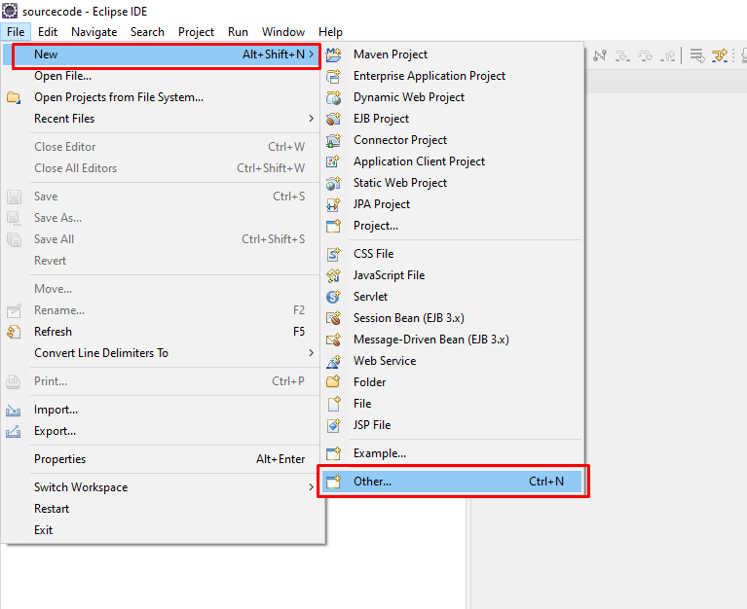

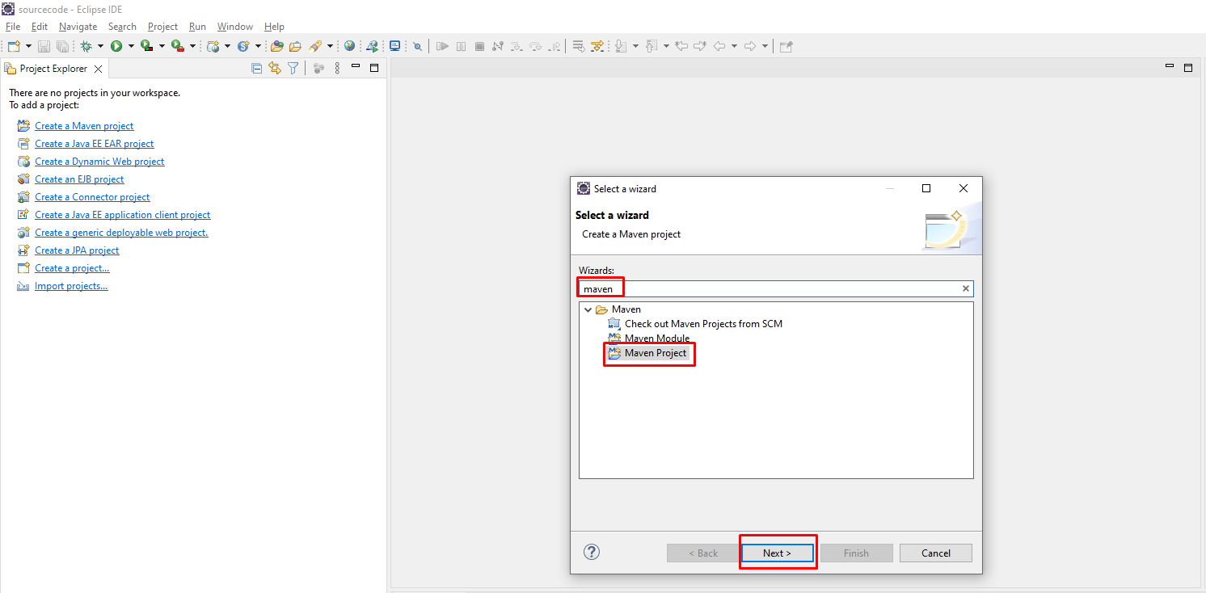

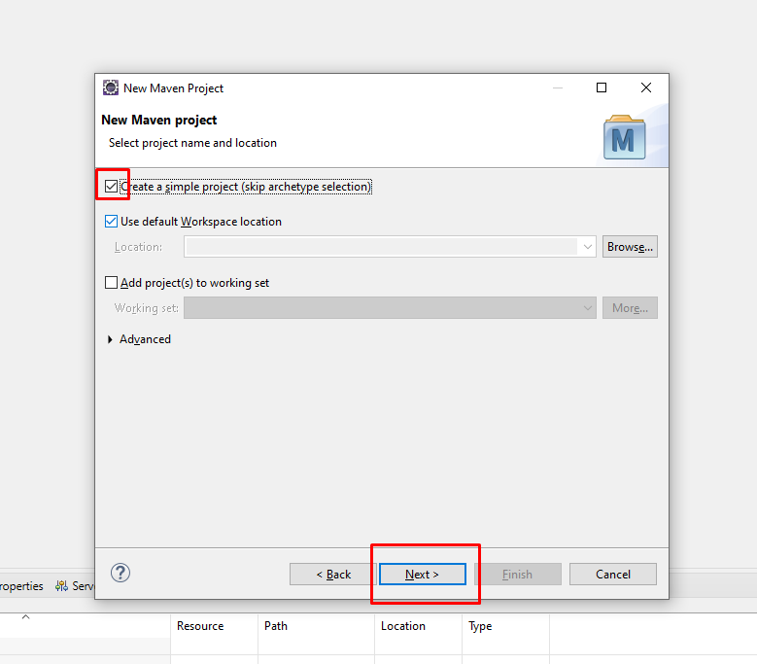

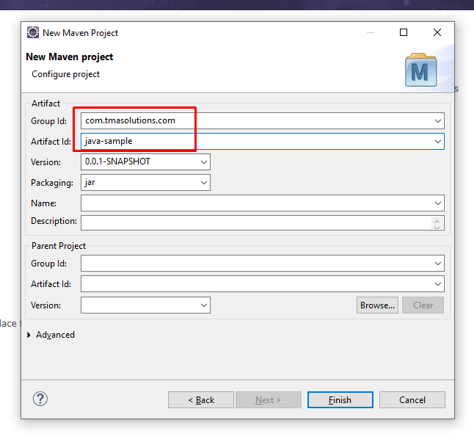

1. Add spring boot libraries to POM

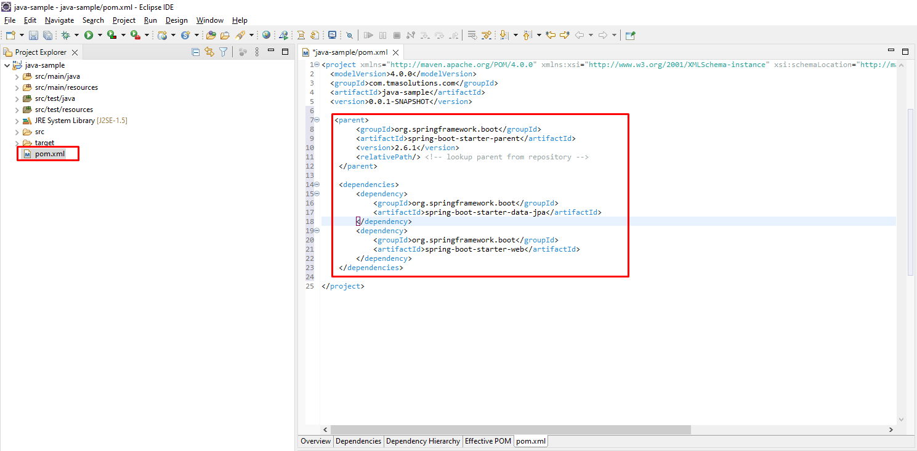

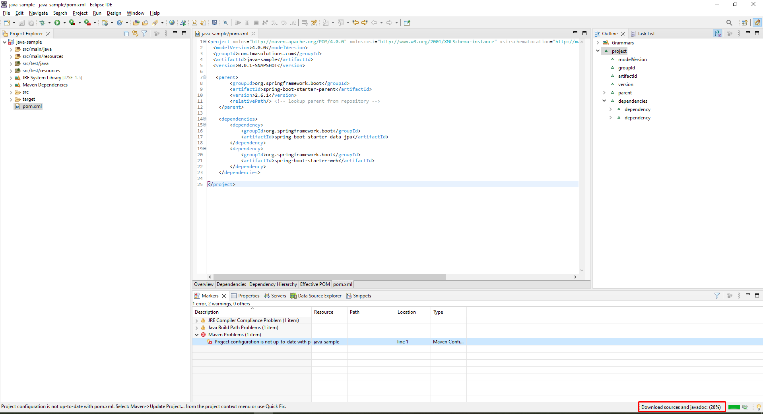

<parent>

<groupId>org.springframework.boot</groupId>

<artifactId>spring-boot-starter-parent</artifactId>

<version>2.6.1</version>

<relativePath/> <!-- lookup parent from repository -->

</parent>

<dependencies>

<dependency>

<groupId>org.springframework.boot</groupId>

<artifactId>spring-boot-starter-data-jpa</artifactId>

</dependency>

<dependency>

<groupId>org.springframework.boot</groupId>

<artifactId>spring-boot-starter-web</artifactId>

</dependency>

</dependencies>

1. Create file “application.properties” and edit content

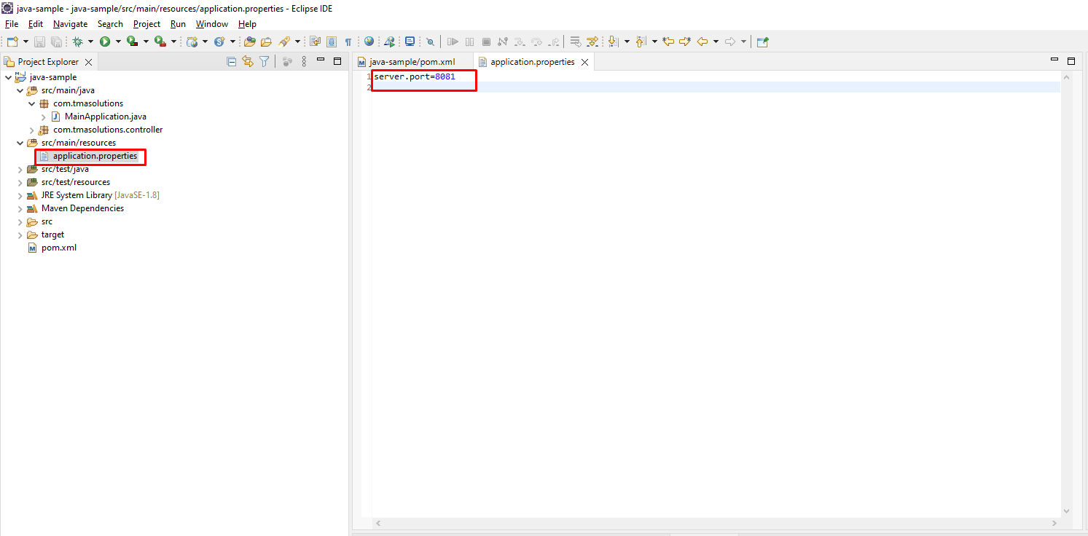

1. Add main package

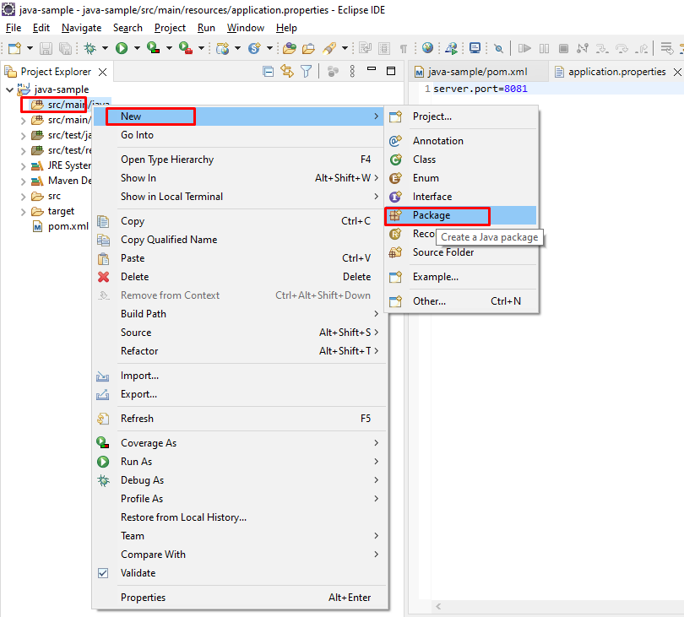

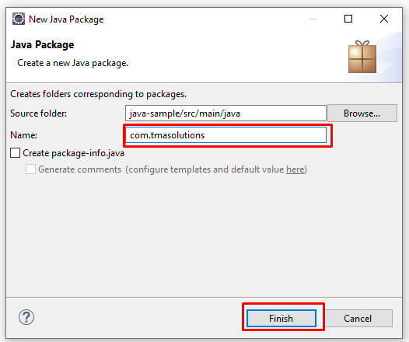

1. Add class MainApplication.java

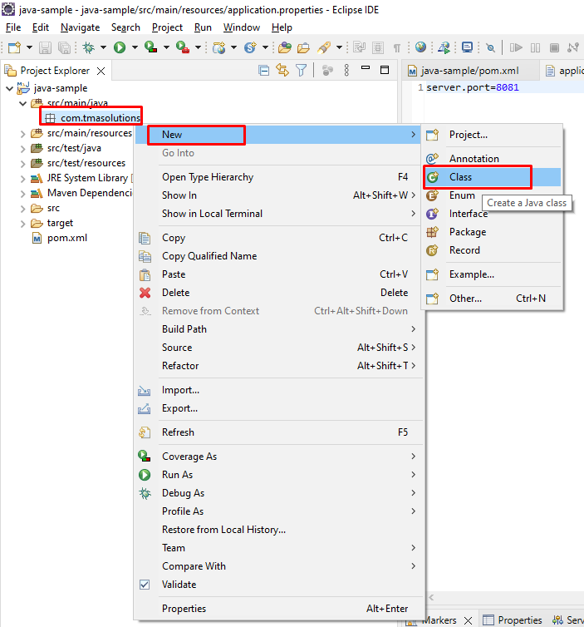

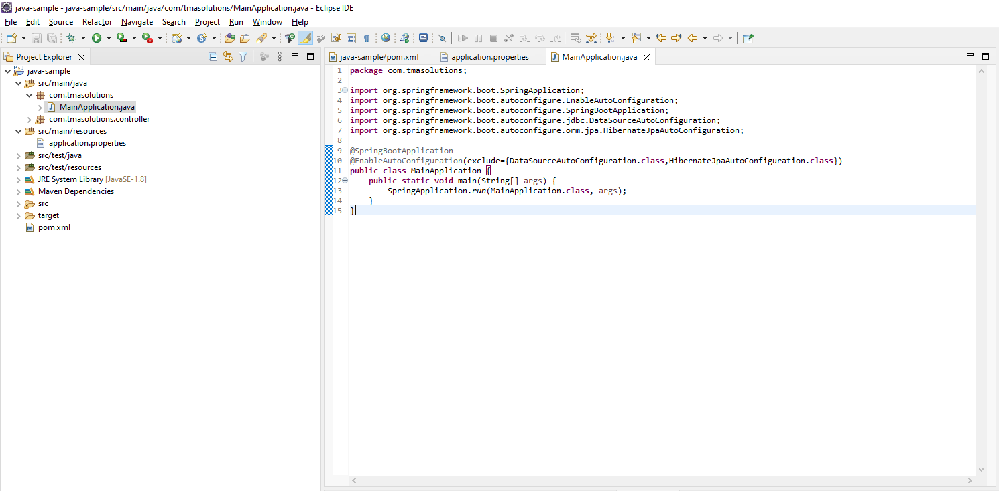

**package** com.tmasolutions;

**import** org.springframework.boot.SpringApplication;

**import** org.springframework.boot.autoconfigure.EnableAutoConfiguration;

**import** org.springframework.boot.autoconfigure.SpringBootApplication;

**import** org.springframework.boot.autoconfigure.jdbc.DataSourceAutoConfiguration;

**import** org.springframework.boot.autoconfigure.orm.jpa.HibernateJpaAutoConfiguration;

@SpringBootApplication

@EnableAutoConfiguration(exclude={DataSourceAutoConfiguration.**class**,HibernateJpaAutoConfiguration.**class**})

**public** **class** MainApplication {

**public** **static** **void** main(String[] args) {

SpringApplication.*run*(MainApplication.**class**, args);

}

}

1. Add first controller “HelloController.java”

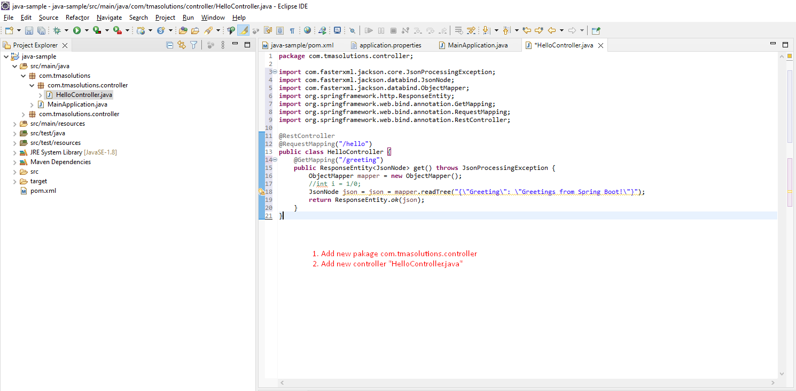

package com.tmasolutions.controller;

import com.fasterxml.jackson.core.JsonProcessingException;

import com.fasterxml.jackson.databind.JsonNode;

import com.fasterxml.jackson.databind.ObjectMapper;

import org.springframework.http.ResponseEntity;

import org.springframework.web.bind.annotation.GetMapping;

import org.springframework.web.bind.annotation.RequestMapping;

import org.springframework.web.bind.annotation.RestController;

@RestController

@RequestMapping("/hello")

public class HelloController {

@GetMapping("/greeting")

public ResponseEntity<JsonNode> greeting() throws JsonProcessingException {

ObjectMapper mapper = new ObjectMapper();

//int i = 1/0;

JsonNode json = json = mapper.readTree("{\"Greeting\": \"Greetings from Spring Boot!\"}");

return ResponseEntity.ok(json);

}

}

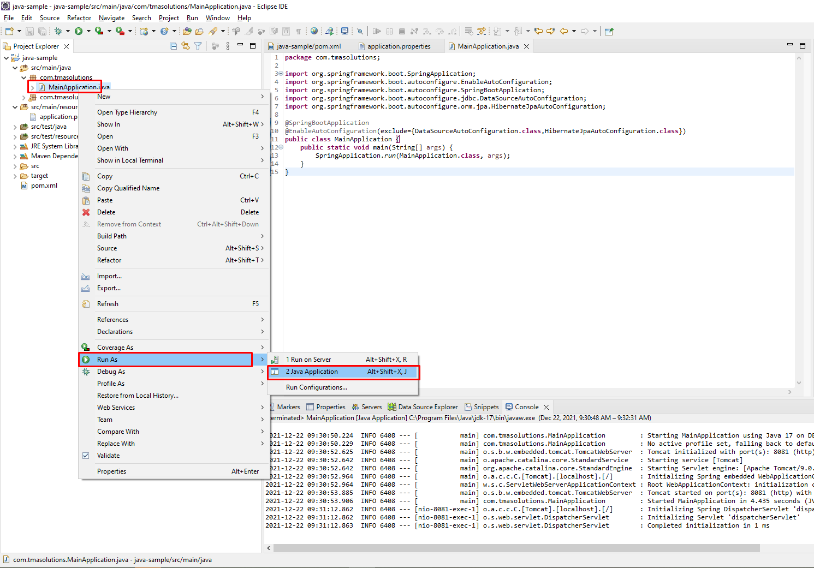

1. Test API success

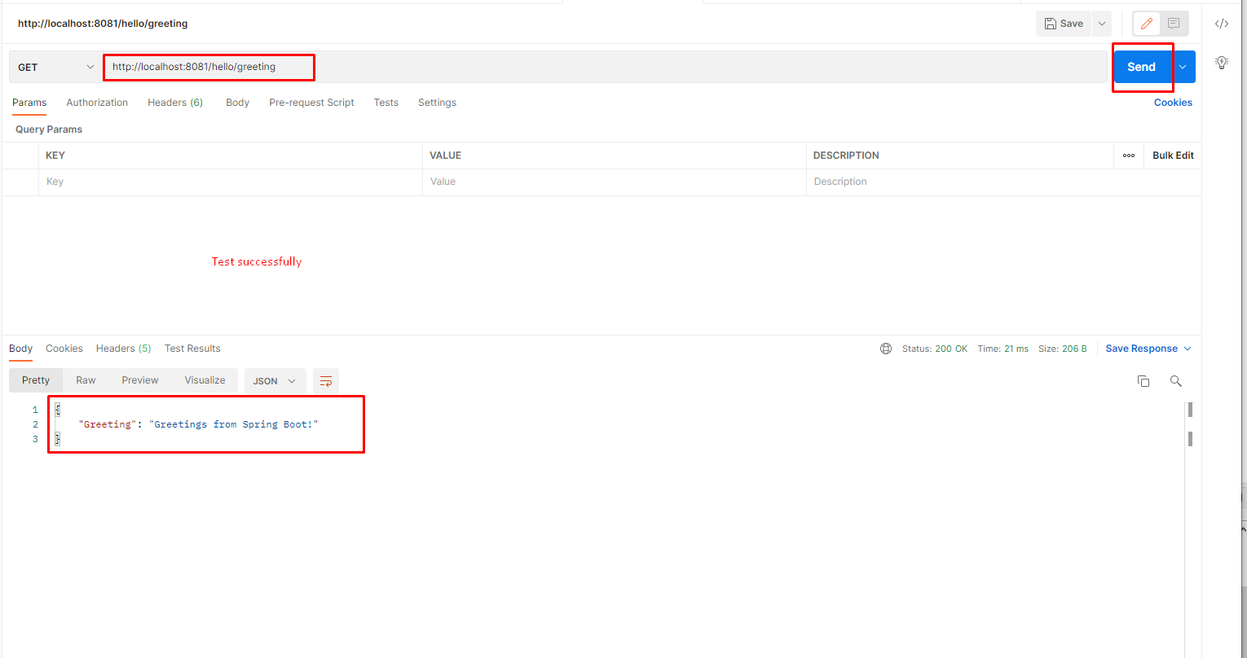

1. **Install swagger**
2. Install Swagger to project

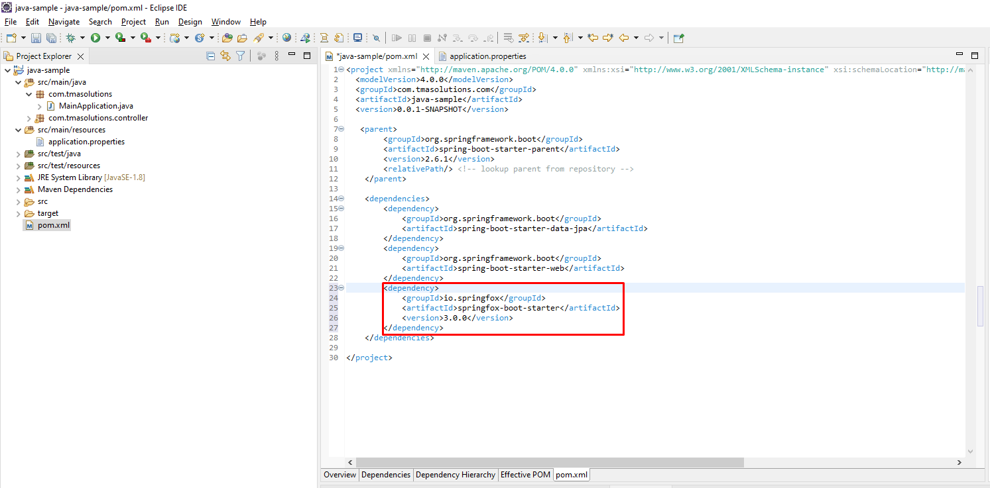

<dependency>

<groupId>io.springfox</groupId>

<artifactId>springfox-boot-starter</artifactId>

<version>3.0.0</version>

</dependency>

1. Add config file for swagger

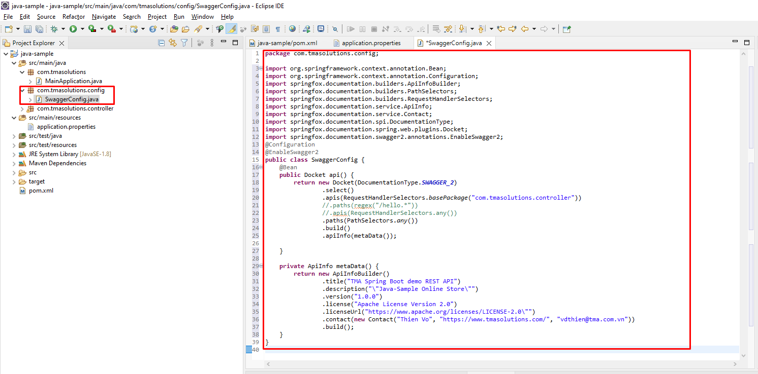

package com.tmasolutions.config;

import org.springframework.context.annotation.Bean;

import org.springframework.context.annotation.Configuration;

import springfox.documentation.builders.ApiInfoBuilder;

import springfox.documentation.builders.PathSelectors;

import springfox.documentation.builders.RequestHandlerSelectors;

import springfox.documentation.service.ApiInfo;

import springfox.documentation.service.Contact;

import springfox.documentation.spi.DocumentationType;

import springfox.documentation.spring.web.plugins.Docket;

import springfox.documentation.swagger2.annotations.EnableSwagger2;

@Configuration

@EnableSwagger2

public class SwaggerConfig {

@Bean

public Docket api() {

return new Docket(DocumentationType.SWAGGER_2)

.select()

.apis(RequestHandlerSelectors.basePackage("com.tmasolutions.controller"))

//.paths(regex("/hello.*"))

//.apis(RequestHandlerSelectors.any())

.paths(PathSelectors.any())

.build()

.apiInfo(metaData());

}

private ApiInfo metaData() {

return new ApiInfoBuilder()

.title("TMA Spring Boot demo REST API")

.description("\"Java-Sample Online Store\"")

.version("1.0.0")

.license("Apache License Version 2.0")

.licenseUrl("https://www.apache.org/licenses/LICENSE-2.0\"")

.contact(new Contact("Thien Vo", "https://www.tmasolutions.com/", "vdthien@tma.com.vn"))

.build();

}

}

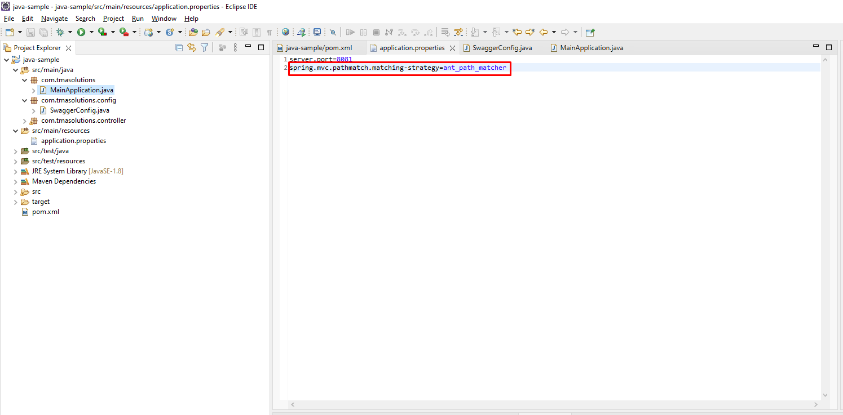

spring.mvc.pathmatch.matching-strategy=ant_path_matcher

1. Test swagger was installed success

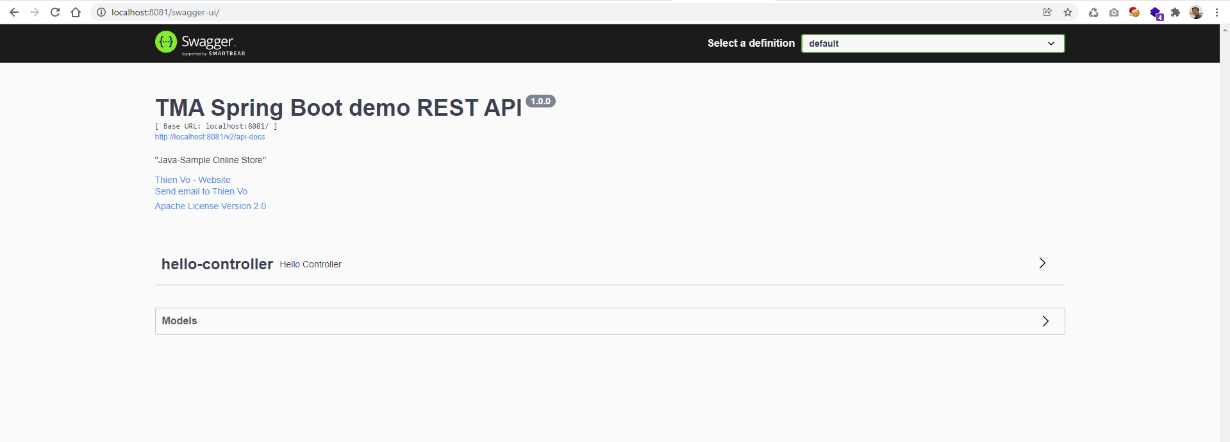

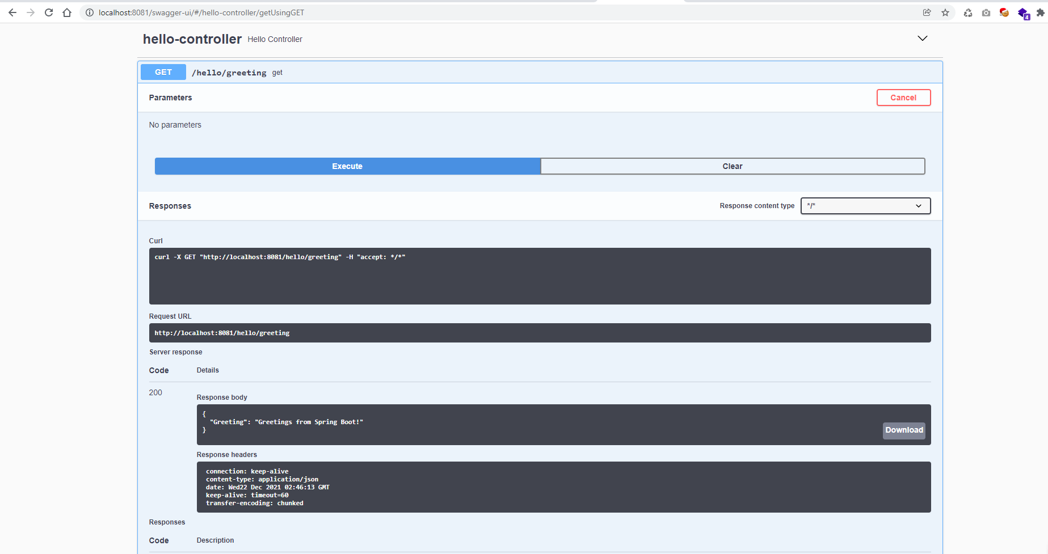

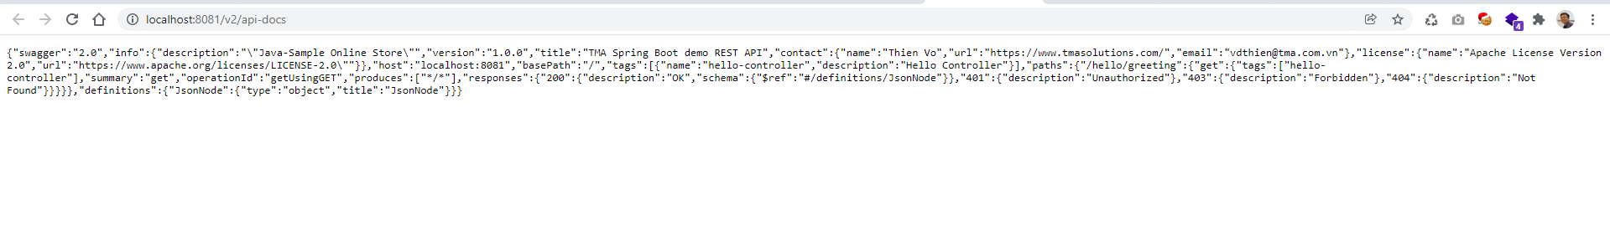

1. Find swagger editor at: <https://editor.swagger.io/>
2. **Build runnable jar file**
3. Build Runnable jar file

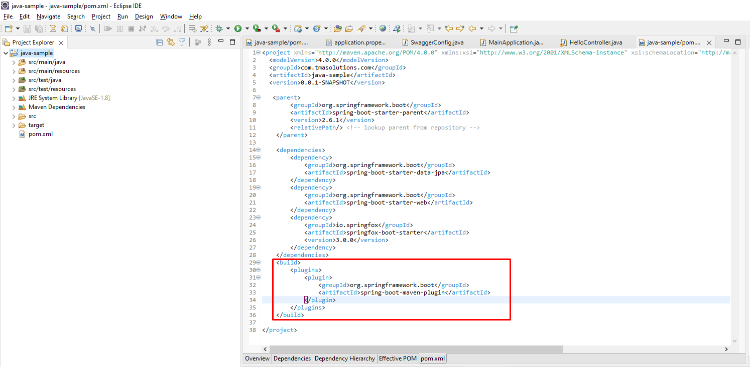

<build>

<plugins>

<plugin>

<groupId>org.springframework.boot</groupId>

<artifactId>spring-boot-maven-plugin</artifactId>

</plugin>

</plugins>

</build>

